2200030216 WEEK-3 Hibernate Query Language and Native Query

We run the above project in the terminal using

mvn spring-boot:run

here we have to change and keep your mysql passcode in the application.properties files this is important

AND AFTER RUNNING YOU WILL GET THIS IMAGE IT MEANS YOUR SPRING IS RUNNING

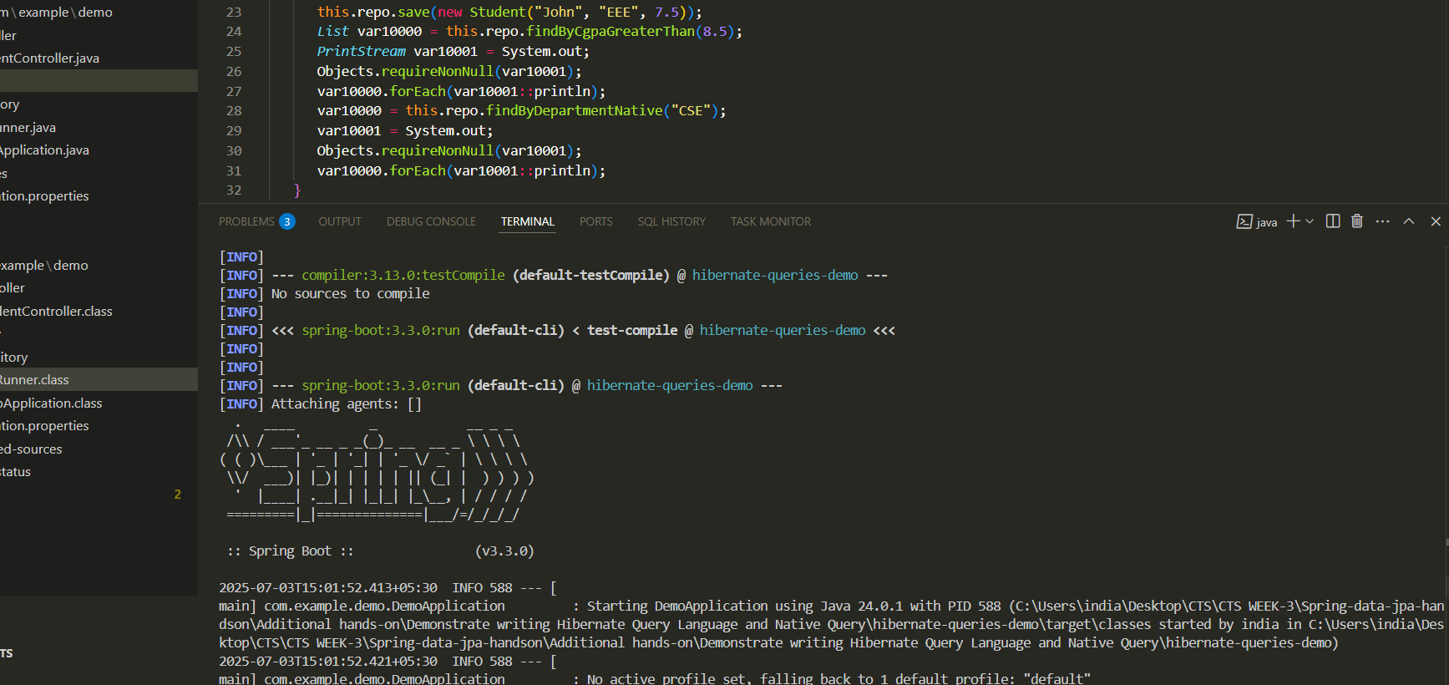

Now to see the out put you use this links   
<http://localhost:8080/api/students>

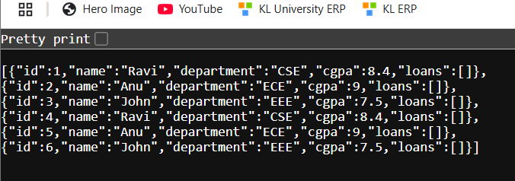

<http://localhost:8080/api/students/dept/CSE>

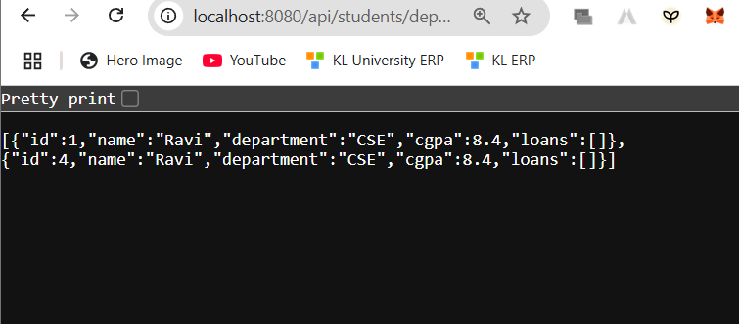

http://localhost:8080/api/students/highcgpa/8.5

